

The Monument Beach Sportsman’s Club is proud to present a
Women’s Only instructional shooting clinic.
Sunday, MAY 7, 2023 – REVISED DATE
7:45 am to 5:30pm
At
The Monument Beach Sportsman’s Club
199 MacArthur Blvd
Bourne, MA

Ladies - if you’ve ever thought about trying your hand at recreational shooting, here is your opportunity! Come join us for a women’s only instructional shooting clinic. You will receive hands on instruction in shotgun, rifle, pistol and archery by the friendly and knowledgeable folks at the Monument Beach Sportsman’s Club. All women are invited to participate regardless of skill level. No previous experience is necessary - just the desire to learn and have fun. For those interested in applying for a Massachusetts firearm license, this class will qualify you to receive your certificate allowing you to apply for a Firearms Identification Card (FID) or your License to Carry (LTC) upon completion of the day.

All equipment and student texts are included. Lunch and refreshments will be served!

This event fee $75- per person and is limited to 50 people. You must be at least 16 years old to participate. REGISTER EARLY – THIS CLASS ALWAYS FILLS QUICKLY AND NO WALK-INS ARE ALLOWED.

Please print out and mail in registration form (page 2) to register (MUST REGISTER BY MAIL). Have questions? - contact Stacy Kehoe @ stkehoe@comcast.net.

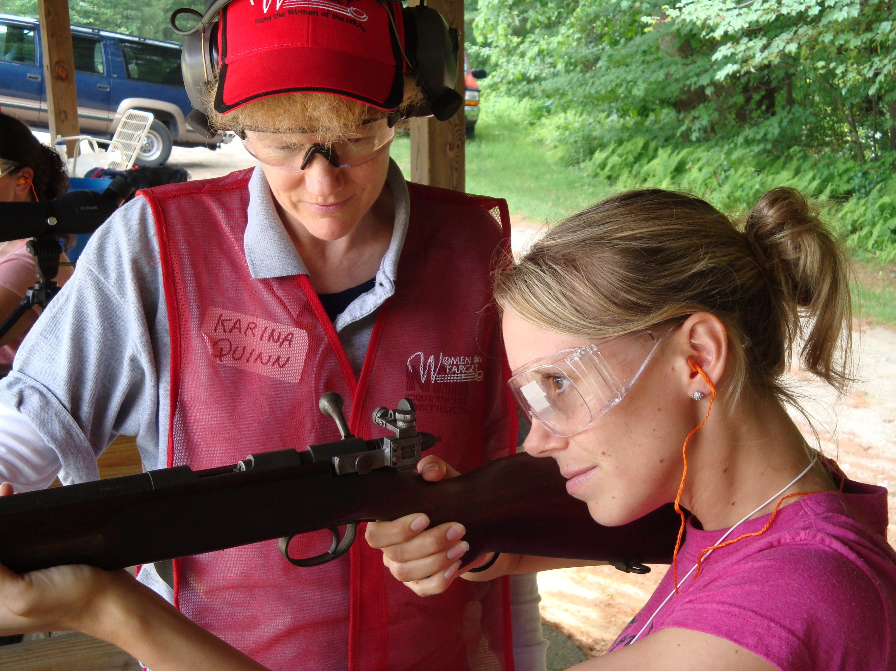

The 2nd Amendment is An Equal Opportunity Civil Right

WOMEN ON TARGET

Where: Monument Beach Sportsman’s Club
199 Dump Road (Off MacArthur Blvd)
Bourne, MA

When: MAY 7, 2023 Start Time: 7:45 a.m. until approx. 5:30 pm

Cost: $75.00 - lunch will be provided

What to Bring: A Great Attitude!

*MBSC will provide eye and ear protection for each participant but feel free to bring your own if you wish. All firearms and ammunition are provided by the Monument Beach Sportsman’s Club.
- - - - - - - - - - - - - - - - - - - - - - - - - - - - - - - - - - - - - - - - - - - - - - - - - - - - - - - - - - - - - -
PLEASE PRINT ALL INFORMATION CLEARLY SO IT IS LEGIBLE

Name: _________________________________________________
*This MUST be your legal name as it will need to appear on your certificate

Address: _______________________________________________
*This MUST be legal address including town of which you reside. PO Box is not acceptable.

DATE OF BIRTH: ________________________________________
*Only needed IF you are NOT currently a License to Carry permit holder. If you already have your LTC, please write LTC on this line; otherwise fill in complete birth date.

Contact EMAIL ADDRESS: ____________________________________
*Confirmation of registration will be sent to this email. If you do not have email, enter phone number. PRINT LEGIBLY PLEASE!

Emergency Contact
Name/Phone: ____________________________________________

Please make check payable to MBSC and mail to:
PO Box 331
Monument Beach, MA 02553
NOTE: Mailing address is DIFFERENT than physical address.

